St Mary's Abbotts Ann
celebrating
Harvest Festival
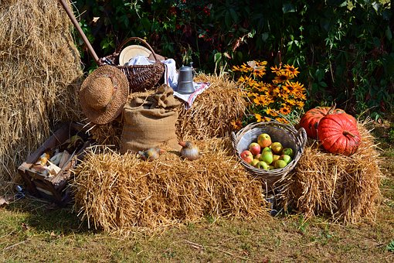
11am Sunday 30th September
Join us for an all-age service at
St Mary’s Church
followed by a bring-and-share lunch
in the War Memorial Hall
(please sign the list in the village shop)

