Abbotts Ann Festival of Motoring

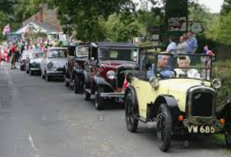
Saturday 5th September

Motoring Procession
Through the Village

Meet 12:30 at the
Church Car Park opposite Church path

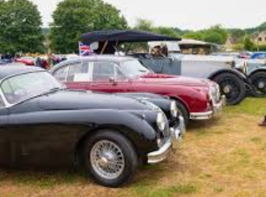
We will drive around the village twice then back to the car park where the cars will be on display.

For more information and to enter your classic car, bike or vehicle please contact:-
Tim Kirby
07982680295
Timk206@btinternet.com

